Olusegun Afolabi
EECE 412
Prof Wenjie
3/4/2024

Lab 6
Introduction
In this lab, we explore the differences between conditional signal assignment and selected signal assignment in VHDL by implementing a given logic table using selected signal assignment. This builds upon the concepts learned in previous labs, where we used conditional signal assignments to prioritize logic operations. The goal is to analyze how selected signal assignment affects the hardware implementation, propagation delay, and resource utilization on the Basys 3 FPGA board. By generating and comparing schematics, we determine the efficiency of this approach relative to conditional signal assignment.
Concept
In VHDL, conditional signal assignment (when-else) evaluates conditions sequentially, similar to an if-else structure, while selected signal assignment (with ... select) evaluates all possible conditions concurrently, behaving like a case statement. Selected signal assignment is advantageous when multiple conditions need to be mapped directly to specific outputs. However, it often requires more hardware resources, as it precomputes all logic operations and uses a multiplexer (MUX) to select the final output. The function table provided in this lab specifies different logic operations (XOR, AND, OR, NOT) that are selected based on a 4-bit control signal (ctrl). The schematic generated in Vivado helps visualize how this approach differs from the conditional signal assignment method used in Lab 5.
Procedure
- Created a New Vivado Project
  - Selected VHDL as the design language.
  - Chose the Basys 3 board as the target FPGA.
- Implemented the Logic from the Table
  - Used the base VHDL code and modified it to implement the function table using selected signal assignment (with ... select).
- Added Design and Constraints Files
  - Added the design file to the Vivado project.
  - Included the Basys 3 constraint file to define pin mappings.
- Ran Linter and Opened Elaborated Design
  - Clicked Run Linter to check for syntax errors.
  - Clicked Open Elaborated Design to generate the schematic.
- Analyzed the Schematic Components
  - Opened the schematic view and identified the logic gates and multiplexer (MUX) used to implement the logic.
  - Mapped each component to its corresponding part in the VHDL code.
- Compared the Schematic to the Manual Diagram
  - Cross-referenced the manually drawn schematic with the Vivado-generated schematic to verify correctness.
- Compared the Schematic to Lab 5’s Schematic
  - Analyzed structural differences between selected signal assignment (Lab 6) and conditional signal assignment (Lab 5).
  - Evaluated differences in MUX implementation, logic structure, and resource utilization.
Components in the Lab 6 Schematic and Their Relation to the Code
The Lab 6 schematic directly reflects the selected signal assignment VHDL code, using a 5-to-1 multiplexer (MUX) to select the appropriate logic operation based on ctrl[3:0].
- Logic Gates: The schematic includes XOR (a xor b), AND (a and b), OR (a or b), and NOT (not a, not b) gates, which match the operations defined in the with ... select statement.
- Multiplexer (MUX): The 5-to-1 MUX selects the correct gate output based on ctrl, implementing the with ctrl select logic.
- Control Signal (ctrl[3:0]): Directly feeds into the MUX as the selection signal, ensuring the correct logic operation is assigned to x.

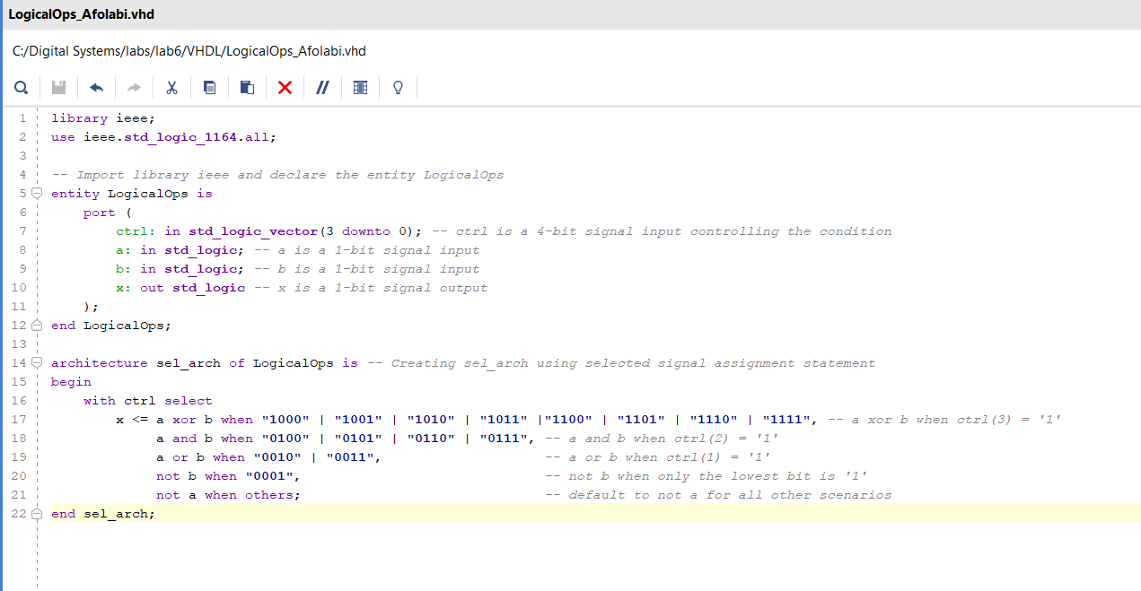
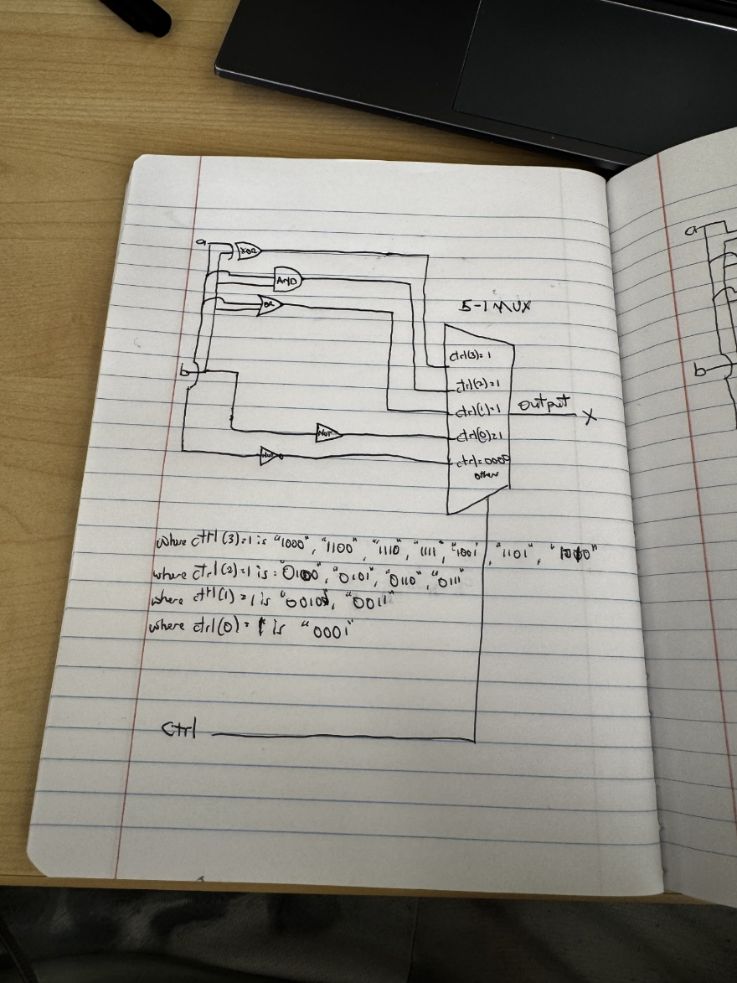

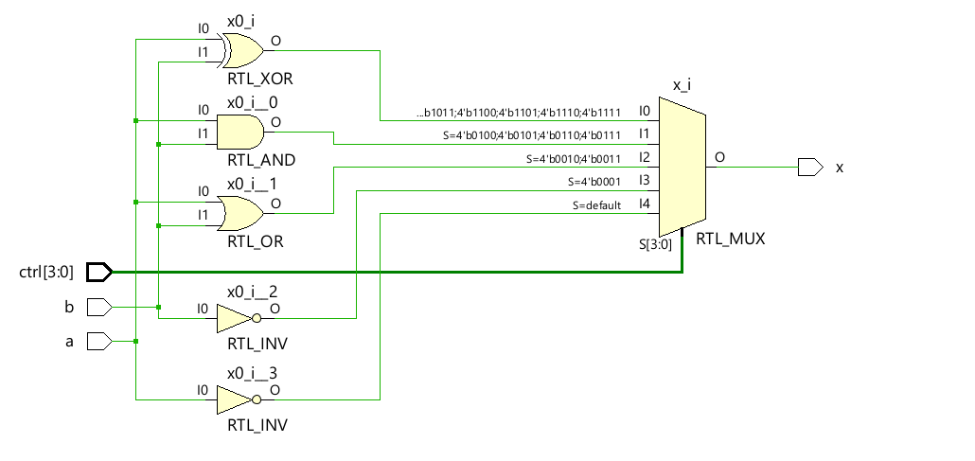
Comparison of manual diagram and vivado schematic
Both the manual and Vivado schematics correctly implement the selected signal assignment logic using XOR, AND, OR, and NOT gates along with a 5-to-1 multiplexer controlled by ctrl[3:0]. The primary difference is in detail—while the manual schematic conceptually represents the logic, the Vivado schematic provides a precise RTL-level implementation with exact bit-level mappings for the multiplexer (S=4'b... conditions). The Vivado version also offers clearer signal routing and formalized synthesis, whereas the manual drawing is more abstract. Functionally, both are equivalent, with no major differences apart from representation style.
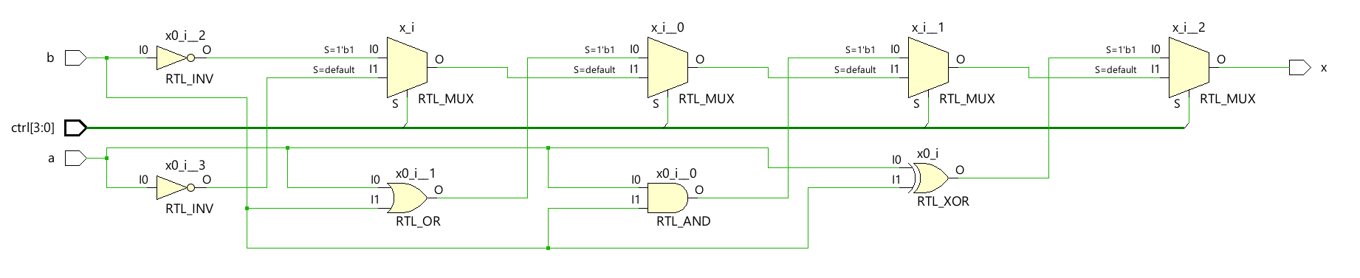
Comparison of Vivado schematic for Lab 6 & 5
Feature | Lab 6 (Selected Assignment) | Lab 5 (Conditional Assignment)
MUX Structure | Uses a single large MUX to select from precomputed logic values. | Uses multiple small MUXes in a cascaded fashion, leading to sequential condition evaluation.
Logic Evaluation | All logic operations are computed in parallel, and the MUX selects one. | Conditions are checked sequentially, making it dependent on earlier evaluations.
Control Mechanism | ctrl[3:0] directly selects the corresponding logic gate output. | ctrl is evaluated from most significant to least significant bit, creating a priority-based structure.
Propagation Delay | Lower delay because all logic is evaluated simultaneously, and only selection occurs. | Higher delay due to cascading dependencies between conditions.
Hardware Utilization | More resource-heavy due to a large MUX handling all cases. | More efficient as only necessary conditions are evaluated in a priority manner.

Which is More Efficient?
- Lab 5 (Conditional Assignment) is more efficient because:
  - It avoids unnecessary computation by evaluating conditions sequentially.
  - It uses fewer hardware resources, as logic gates only activate based on control conditions.
  - The cascading nature reduces MUX complexity, making it more efficient in terms of FPGA logic resource utilization.
- Lab 6 (Selected Assignment) is less efficient because:
  - All logic operations (XOR, AND, OR, NOT) are always active, even if not selected.
  - A larger multiplexer increases FPGA resource usage.
  - The design is more suited for fully parallel computation but is not optimized for priority-based logic.
Conclusion
This lab demonstrated how selected signal assignment in VHDL translates into hardware by precomputing all logic operations and using a multiplexer for selection. The schematic confirmed that this approach results in a single large MUX selecting the correct logic operation, unlike Lab 5’s cascaded priority structure. Comparing both methods, Lab 5’s conditional assignment was more efficient, as it only evaluated the necessary logic conditions, reducing hardware usage. While selected signal assignment allows for a structured and parallel approach, it increases FPGA resource consumption, making it less optimal for designs requiring minimal logic utilization.

